Unit 5: Agriculture Human Geography

Match the correct agricultural regions with the correct type of farming
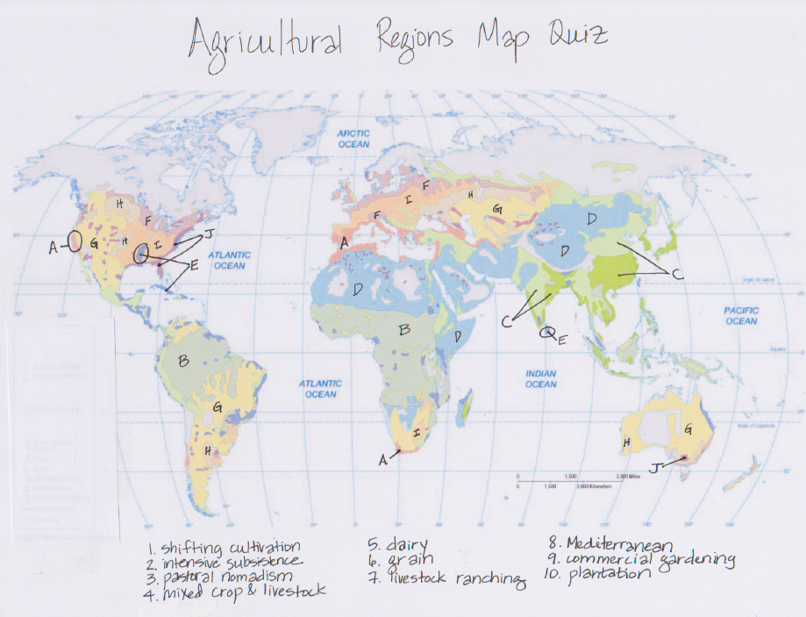
- _____ Shifting cultivation
- _____ Intensive subsistence
- _____ Pastoral Nomadism
- _____ Mixed Crop and Livestock
- _____ Dairy Farming
- _____ Grain Farming
- _____ Livestock Ranching
- _____ Mediterranean Farming
- _____ Commercial Gardening
- _____ Plantation Farming

Agricultural terms Matching
- _____ Green Revolution
- _____ Agricultural Revolution
- _____ 2nd Agricultural Revolution
- _____ Subsistence Agriculture
- _____ Commercial Agriculture
- _____ Columbian Exchange
- _____ Extensive Cultivation
- _____ Intensive Cultivation
- _____ Shifting Cultivation
- _____ Pastoral Nomadism
- _____ Transhumance
- _____ Intensive Subsistence Farming
- _____ Crop Rotation
- _____ Mixed Crop and Livestock Farming
- _____ Dairy Farming
- _____ Milkshed
- _____ Grain Farming
- _____ Ranching
- _____ Mediterranean Agriculture
- _____ Commercial Gardening
- _____ Plantation Farming
- _____ Aquaculture
- _____ Von Thunen’s Model
- _____ Overproduction
- _____ Sustainable Agriculture
- _____ Ridge Tillage
- _____ Topsoil Loss
- _____ Salinization
- _____ Desertification
- _____ Urban Sprawl
- _____ Organic Agriculture
- _____ Agribusiness
- _____ Metes and Bounds Survey Method
- _____ Township and Range Survey Method
- _____ Long Lot Survey Method
- _____ Linear Rural Settlement
- _____ Clustered Rural Settlement
- _____ Dispersed Rural Settlement
- _____ Land Rent Curve
- _____ Food Desert
- _____ Economies of Scale
- _____ Community-supported Agriculture (CSA)
- _____ Value-added speciality crops
- _____ Local Food Movements
- _____ Fair Trade

- Rapid growth of cities in MDCs caused demand for milk to increase. Often located near urban areas. Labor-intensive because the cows much be milked twice a day
- over thousands of years, plant cultivation apparently evolved from a combo of accident and deliberate experiment, Happened around 10,000 years ago
- Crops are fed to animals, livestock supply manure to improve soil fertility to grow more crops. Crop rotation is used. Ex. Corn belt in US. Most common commercial agriculture west of Appalachians and Europe
- rejects or limits the use of fertilizers, pesticides, hormones, antibiotics, additives, and GMOs
- Urbanization caused more demand for food, mechanization helped reduce human hands with agricultural technology, transportation was made easier
- ring surrounding a city from which milk can be supplied without spoiling
- seasonal migration of livestock between mountains and lowland pasture areas
- 1970s, development of higher-yield and fast-growing crops through increased technology, pesticides, and fertilizers transferred from MDCs to LDCs
- expansion of human populations away from central urban areas into previously remote and rural areas, often resulting in communities reliant on heavy car usage
- crops grown primarily for consumption by humans rather than livestock. Ex. Wheat belt. Often uses reaper or combine that permits large scale production
- farming as part of a larger food-production system
- found in LDCs, production of food primarily for consumption by the farmer's family
- commercial grazing of livestock over an extensive area. Semi-arid and arid, vegetation too sparse or soil is too poor. Hard to transport meat
- found in MDCs, production of food primarily for sale off the farm
- Herding of domesticated animals. Dry, mountainous climates such as North Africa. Live off the grain and animal products.
- process by which formerly fertile lands becomes increasingly arid, unproductive and desert-like
- practice of rotating use of different fields from crop to crop each year to avoid exhausting in soil
- Higher agricultural density. These feed most LDCs. Most of the work is done by hand. Waste virtually no land. Two types: Wet Rice Dominant and Wet rice not dominant
- system of planting crops on ridge tops- lower production costs, conserves soil
- widespread transfer of plants, animals, culture, people, technology, and diseases between Americas, West Africa and Europe (Old world and New World) in 15th-16th centuries
- efficient agricultural practices create too much food even though demand is the same due to market saturation.
- soils in arid areas are brought under cultivation through irrigation, leaves a salty residue which makes soil infertile
- Tropics and subtropics. Use large farms that specialize in 1 od 2 crops such as cotton, sugarcane, rubber, palm oil. Import a large labor force
- dispersed, widespread ranching and farming, more traditional, less labor, often specific product
- U.S. southeast because of long growing season, humid. Truck farming, use many machines
- smaller plots of land with large labor inputs to generate greater yields, capital-intensive- uses mechanical tools, labor-intensive-uses human labor
- Farming of crustaceans, molluscs, aquatic plants, algae, and other organisms in freshwater or saltwater in controlled conditions
- Compares cost of land and cost of transporting products to market vs. value of yield per hectare. Crops with higher transportation costs are closer to the market
- preserves and enhances environmental quality. Includes sensitive land management, limited use of chemicals, and integrated crop and livestock
- near the sea, west part of continent so winds give moderate winter temperature. Horticulture- growing of fruits, vegetables, and flowers such as olives and grapes
- erosion due to fragile soil, steep slopes or a lot of rain
- Humid low-latitude climate- regions with high temps and abundant rain such as tropics. Also called slash-and-burn agriculture. Grow crops on a cleared field (swidden) for only a few years until soil nutrients are depleted then do not plant anything so soil can recover. 25% of world land area
- land survey method used for the original 13 colonies, boundaries are made using a combo of metes (measurements using compass direction/distance measurements) and bounds using general landmarks
- an area that has limited access to affordable and nutritious food
- Public Land Survey System, divides land into 6 mile square townships. Township designations indicate the location north or south of the baseline, and range designations indicate the location east or west of the Principal Meridian.
- cost per unit of output decreases with increasing scale for an industry
- Less interested in farming and more interested in fur trading so needed lots that touched the river and road
- allows the consumer to subscribe to the harvest of a certain farm or group of farms which connects consumers and producers more closely in the larger food system. In return for subscribing to a harvest, subscribers receive either a weekly or bi-weekly box of produce or other farm goods.
- settlement formed in a long line, often due to a river, or coast
- Determines which types of agriculture goes where based on cost to get to market, land cost and profit from agricultural products
- a number of families live in close proximity to each other, with fields surrounding the collection of houses and farm buildings
- food that is produced close to where it is consumed. Ex: Farmers’ markets
- manufacturing processes that increase the value of primary agricultural commodities Ex. Organic produce, free-range chickens
- typical of the North American rural landscape, is characterized by farmers living on individual farms isolated from neighbors rather than alongside other farmers in settlements
- trade agreement in which producers/workers of developing countries get better social and environmental working conditions and a higher amount of money for their products

Von Thunen Model

Place each of the following types of Agriculture in the correct ring according to Von Thunen’s Model of Rural Land Use. There are sometimes more than one type in each ring
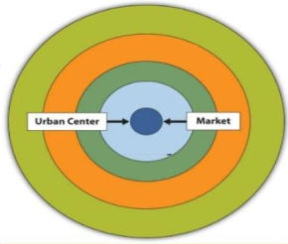
- Forestry
- Ranching
- Commercial Gardening
- Grain Farming
- Dairy

Why does each of these types of farming go in that ring?
__________________________________________________
__________________________________________________
__________________________________________________
__________________________________________________

Name whether each of the following types of agriculture are 1) intensive or extensive 2) subsistence or commercial and 3) name a country or region where that type exists
- Dairy farming
1)______________________2)_______________________3)____________________
- Pastoral Nomadism
1)______________________2)_______________________3)_____________________
- Grain farming
1)______________________2)_______________________3)____________________
- Mixed Crop and Livestock 1)______________________2)_______________________3)____________________
- Shifting Cultivation
1)_____________________2)_______________________3)_____________________
- Intensive Subsistence Wet Rice Dominant 1)______________________2)_______________________3)____________________
- Mediterranean Farming 1)______________________2)_______________________3)____________________
- Commercial Gardening 1)______________________2)_______________________3)____________________
- Intensive Subsistence Wet Rice Not Dominant 1)______________________2)_______________________3)____________________
- Plantation Farming 1)______________________2)_______________________3)____________________
- Livestock Ranching
1)______________________2)_______________________3)____________________

Fill in the Blank with the agricultural concept that matches each example (there are multiple correct answers for some of them)
- _______________________________ Ex: Farmers’ markets
- _______________________________ Ex: Free Range Chickens
- _______________________________ Ex: Food subscription services
- _______________________________Ex: People in Baltimore City not having a grocery store near them to get fresh food
- _______________________________ Ex: Growing plants on a rooftop in the city
- _______________________________ Ex: When coffee plantation workers in LDCs get more money for their coffee products and better working hours/conditions

Identify the rural settlement pattern or rural survey pattern from the photo
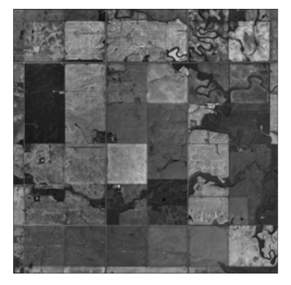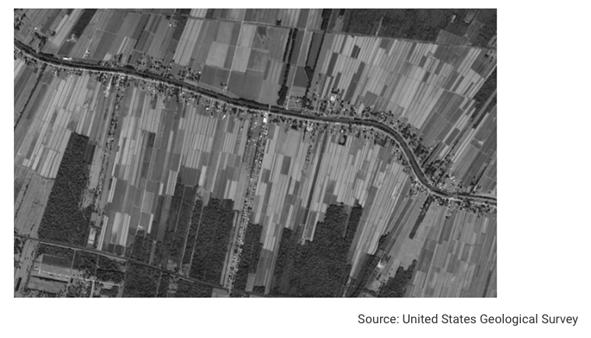
______________________________ ___________________________________

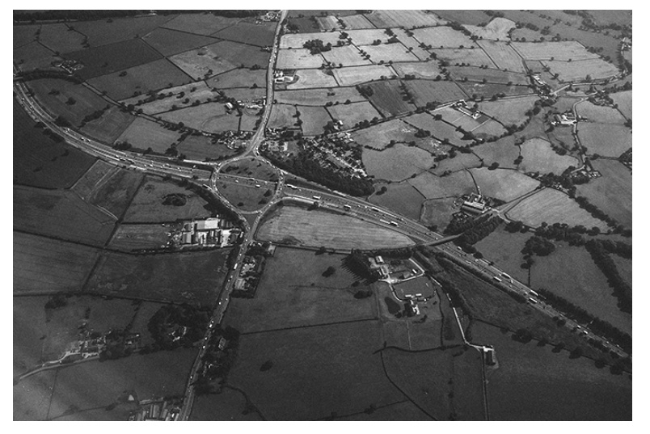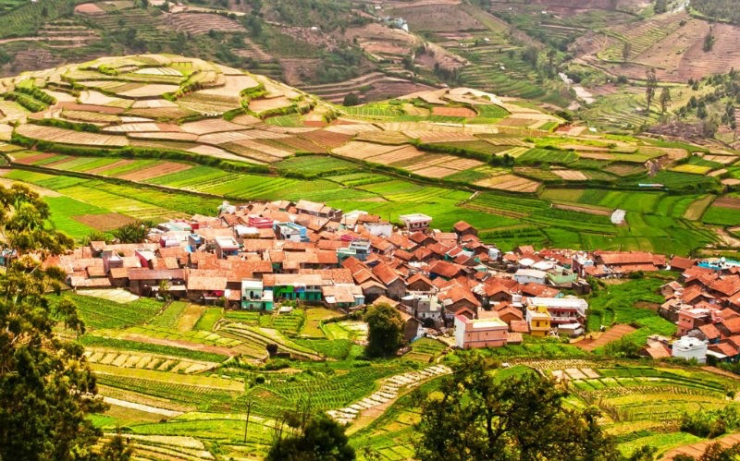
__________________________________ ___________________________________

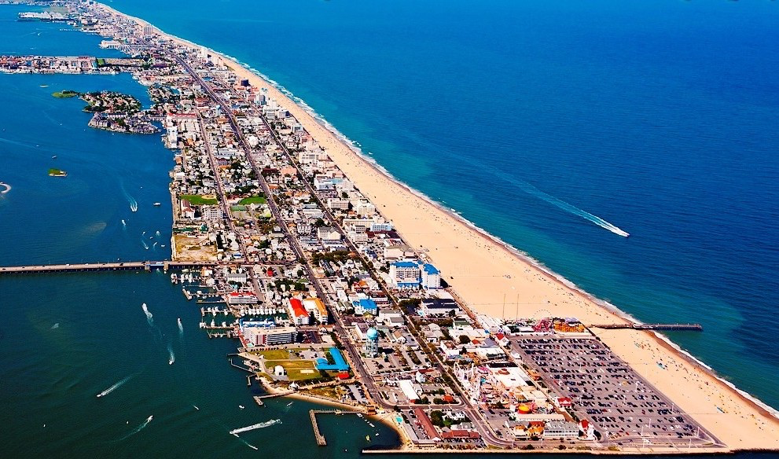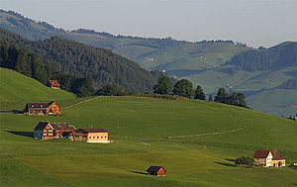
______________________________ ___________________________________

Multiple Choice
- The Industrial Revolution transformed Western agriculture
  - Through mechanization and the creation of new markets
  - With biotechnology
  - Through technological and religious change
  - By eliminating agricultural pests
  - By eliminating plant hybridization

- Ranching is a good example of which type of agricultural system?
  - Intensive subsistence cultivation
  - Extensive commercial cultivation
  - Labor-intensive agriculture
  - Capital intensive agriculture
  - Controlled agriculture

- All of the following are plantation crops EXCEPT
  - Cotton
  - Tea
  - Sugarcane
  - Rubber
  - Wheat

- Which of the following methods of farming has become more popular in response to the widespread use of pesticides in farming?
  - Slash-and-burn agriculture
  - Crop rotation
  - Organic farming
  - Shifting cultivation
  - Agricultural industrialization

- Herders who move herds constantly in order to find food sources as old sources are depleted engage in
  - Shifting cultivation
  - Pastoral nomadism
  - Commercial farming
  - Agropastoralism
  - Sedentarization

- Which of the following is an benefit of industrial agriculture?
  - It uses fewer fossil fuels.
  - It gives consumers more access to food.
  - It conserves water through irrigation
  - It increases the number of farming jobs
  - It decreases the amount of chemical fertilizers running off farm fields

- A direct result of the U.S. farm crisis is
  - More jobs available in the farming industry
  - Less food available for consumption
  - A decrease in the number of small farms
  - Increased price of crops for consumers
  - Higher profits for farmers

- Which of the following best characterizes the Green Revolution?
  - The Green Revolution relied solely on technology to increase crop yields in the years following WWII.
  - The Green Revolution resulted in increased biodiversity worldwide, especially in places where monocropping and high-yield varietals were prevalent.
  - The Green Revolution was able to increase crop yields and food production in many locations throughout the world, but its impact on the environment, geopolitics, and the world economy has yet to be fully understood.
  - There has been no major famines since the agricultural practices of the Green Revolution took hold in the 1960s.
  - Much more land was put under cultivation during the Green Revolution, and this, rather than the development of high-yield varietals, was responsible for the increase in food production from 1960 to 1985.

- The domestication of plants and animals occurred in the
  - First Agricultural Revolution
  - Green Revolution
  - Second Agricultural Revolution
  - Columbian Exchange
  - Industrial Revolution

- What agricultural practice is employed by people who moved from place to place with their cattle?
  - Dairying
  - Intensive subsistence
  - Ranching
  - Shifting cultivation
  - Pastoral nomadism

- Which describes a change in agriculture that shows the clearest impact of development of agribusiness?
  - The small-scale farming sector has grown stronger.
  - The number of farmers involved in sustainable agriculture has increased dramatically
  - The use of organic farming methods has increased greatly.
  - The networks for production and distribution have become more efficient.
  - The emphasis on local trade has increased significantly.

- Which statement best explains why a large number of agricultural products are imported into the United States from Chile?
  - Inexpensive labor in Chile reduces the cost of production.
  - The growing season in Chile allows U.S. consumers to have fresh fruits and vegetables in the winter.
  - Subsides in the United States make agricultural products less expensive.
  - Improvements in agricultural technologies have increases Chile’s output.
  - The number of U.S. farmers has declined so significantly that the country cannot produce enough food for consumers.

- Which aspect of von Thunen’s Model has changed as a result of developments in transportation?
  - The market is no longer at the center.
  - The width of the rings has increased
  - The width of the rings has decreased
  - The rings now stretch along rivers
  - The model now includes a ring for transportation

- Which lists products in the order in which they will be produced, starting closest to the market, according to von Thunen’s Model?
  - Grain, forest, beef cattle, dairy cattle
  - Tomatoes, grain, forest, beef cattle
  - Dairy cattle, beef cattle, forest
  - Dairy cattle, forest, grain, beef cattle
  - Forest, tomatoes, beef cattle, dairy cattle

- Which of the following is not part of vertical integration in agriculture?
  - Traditional family farms
  - Rail lines
  - Supermarkets
  - marketing/advertising
  - Processing centers

