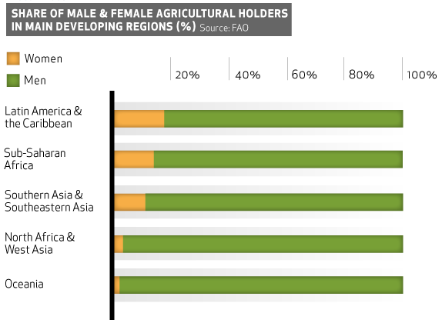
- Identify one reason that explains the disparities between male & female agricultural land holders in developing regions.
- Explain one benefit of women having an expanded role in food production industries.
- Describe the global relationship between women in the workplace and food security.
- Identify one barrier that women face within the agriculture industry.
Explain one way that a government can help close the gap between men and women in agriculture.

Scroll to the next page for answers:

A. Needs ONE of the following. (1 pt.)
- Where women hold land, their plots are generally smaller, of an inferior quality, and with less secure rights than those held by men.
- In most developing countries women enjoy limited to no benefits from extension and training in new crop varieties and technologies.
- Women have less access to credit (to buy fertilizers/seeds and tools) in developing regions.

B. Needs the following. (1 pt.)
- An expanded role for women affects the types of food a family consumes and the way food is prepared because when women are able to manage the family income, they spend more on foods that are nourishing. An expanded role in agriculture reduces child malnutrition by providing meals that are more “complete”.

C. Needs ONE of the following. (1 pt.)
- In most developing countries, women play important roles in household food security as income earners, nurturers, and managers of natural resources, although the success with which they are able to execute these roles is often affected by restricted access to land, labour, capital and technology.
- In the developing world women are also expected to do the house work with no compensation. This expectation is not as prevalent in the developed world. Which takes time away for them to provide food for the family.

D. Needs ONE of the following. (1 pt.)
- Lack of equal access to land/ lack of land rights (inheritance)
- Lack of education / Lack of agricultural training
- Lack of capital (seeds, water, tools, technologies)
- Lack of legal advice to secure property rights.
- Discriminaiton is different in MDC’s and LDC’s. In MDC’s the discrimination is most likely to appear in the marketplace and from male farmers less likely to cooperate with their female counterparts. In LDC’s the discrimination women typically face is systemic in the form of laws prohibiting their equal involvement due to land rights, traditional gender roles, access to markets, and equal pay.

E. Needs ONE of the following. (1 pt.)
- A government could begin by granting women the legal rights to own land / provide legal counsel.
- Provide women microloans or subsidies to capital (tools & technology). This will give women a higher level of independence that will help female-headed households to enter this line of work, which will increase the production of food dramatically.
- Government appointments on agricultural committees to allow women to make more decisions over the crops they are planting making it easier and more efficient for them to grow crops.
- Create programs geared towards women agricultural education.

