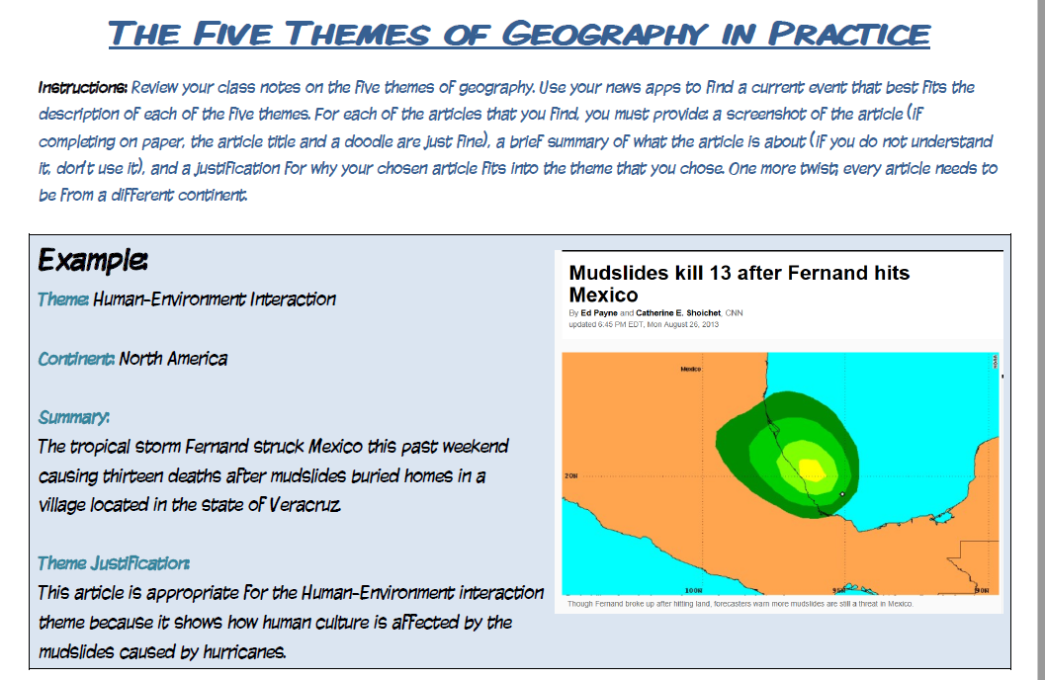

Source:

Theme:

Continent:

Summary:

Theme Justification:

Source:

Theme:

Continent:

Summary:

Theme Justification:
Source:

Theme:

Continent:

Summary:

Theme Justification:
Source:

Theme:

Continent:

Summary:

Theme Justification:

Source:

Theme:

Continent:

Summary:

Theme Justification:
Source:

Theme:

Continent:

Summary:

Theme Justification:
Source:

Theme:

Continent:

Summary:

Theme Justification:

