7.2 One-Pager Directions
- All work must be on one side of an 8.5x11 sheet of computer paper. You may use card stock as long as the dimensions are the same.
- Start with a border that reflects the unit of learning. This can include words, pictures, symbols, or even quotes.
- Give it a title. The title should make sense but can be creative.
- Explain each of the following:
  - Economic Sectors
    - Primary
    - Secondary
    - Tertiary
    - Quarternary
    - Quinary
  - Influences on the location of manufacturing
    - Labor
    - Transportation
    - Break-of-bulk point
    - Least Cost Theory
    - Markets
    - Resources
- Draw three visuals. These could be things, maps, or people.
- Locate and describe a current event relevant to the topic of industrialization and transportation.
- Complete the stem “I learned…”
- Complete the stem “I believe…”
Be colorful and neat. Your entire page should be filled with these elements. If you have more room, you may choose to repeat any of the previous. Nothing should be left in pencil.

One Pager FAQs
- Can I just do a powerpoint instead?
  - No. That defeats the purpose. CREATE.
- I am terrible at drawing. Can I just print and paste some pics?
  - No. I’m not grading your artistic skill level, so you just have to try.
- Can I just write out all the definitions for the KI?
  - No. That doesn’t answer the KI questions. See #4 above.
- Am I doing one of these for each of the chapters in this unit?
  - Yep. See the individual due dates for these.
- How am I turning this in?
  - You’re going to take a picture of each chapter by the respective due date and upload it to Canvas so I can grade it. Make sure the writing is legible in the image, please.
- Is there a template?
  - Sure. It’s not required - you can set it up however you like - but I have some templates you can use if you need a boost. They’re linked on Canvas. Print and use!
- What materials should I use?
  - Colored pencils, ultra-fine Sharpies or Flair markers, and white printer paper. Leavell has all of that and you can use it in her room. You DO NOT need to purchase anything to complete this.
- Wait - I can’t use regular markers?
  - NO. NO. NO. NOOOOOOOO.
Each one pager will be graded using the following:

 | 5 | 3 | 1
Formatting and Components | Size, color, neatness, and layout are appropriate for the task. All required components are present. White space is minimal. | Size, color, neatness, and layout are appropriate for the task. One required element is missing. | Size, color, neatness, and/or layout are not appropriate for the task. More than one required element is missing. Space is not used sufficiently.
Evidence of Thinking | Responses to key issues demonstrate synthesis of chapter information and provide a succinct overview of appropriate content. Current event, “I learned,” and “I believe” statements demonstrate application and analysis of learning. Images and borders are complete and relevant to content. | Responses to key issues demonstrate understanding of chapter information. Current event, “I learned,” and “I believe” statements demonstrate understanding of learning. Images and borders are incomplete or irrelevant to content. | Responses to key issues simply restate chapter information. Current event, “I learned,” and “I believe” statements do not demonstrate understanding of learning. Images and borders are incomplete or irrelevant to content.
Met Deadline | Turned in on time. | n/a | Not turned in on time.

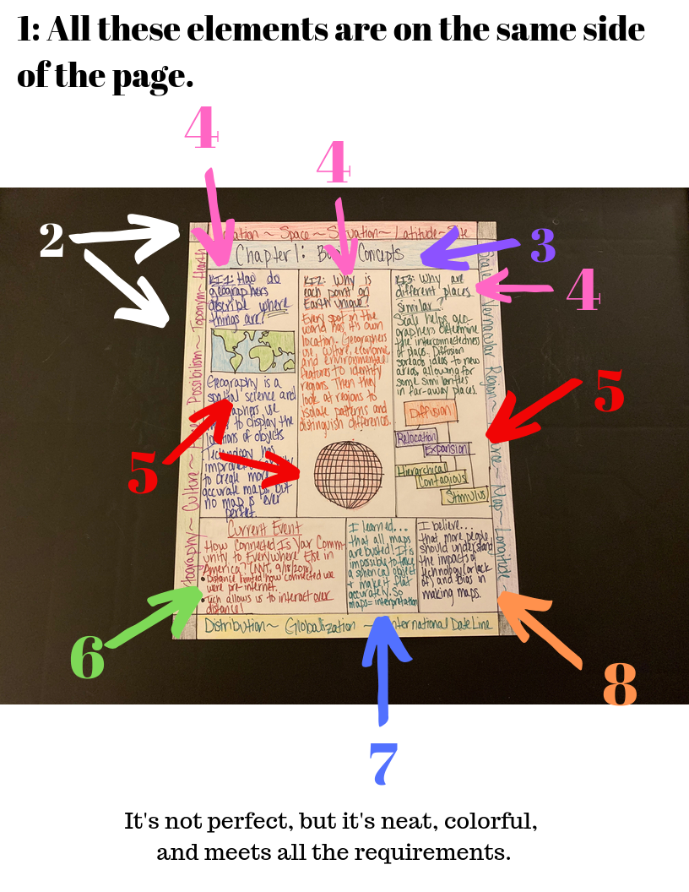
Step 1: Outline your borders. Use pencil.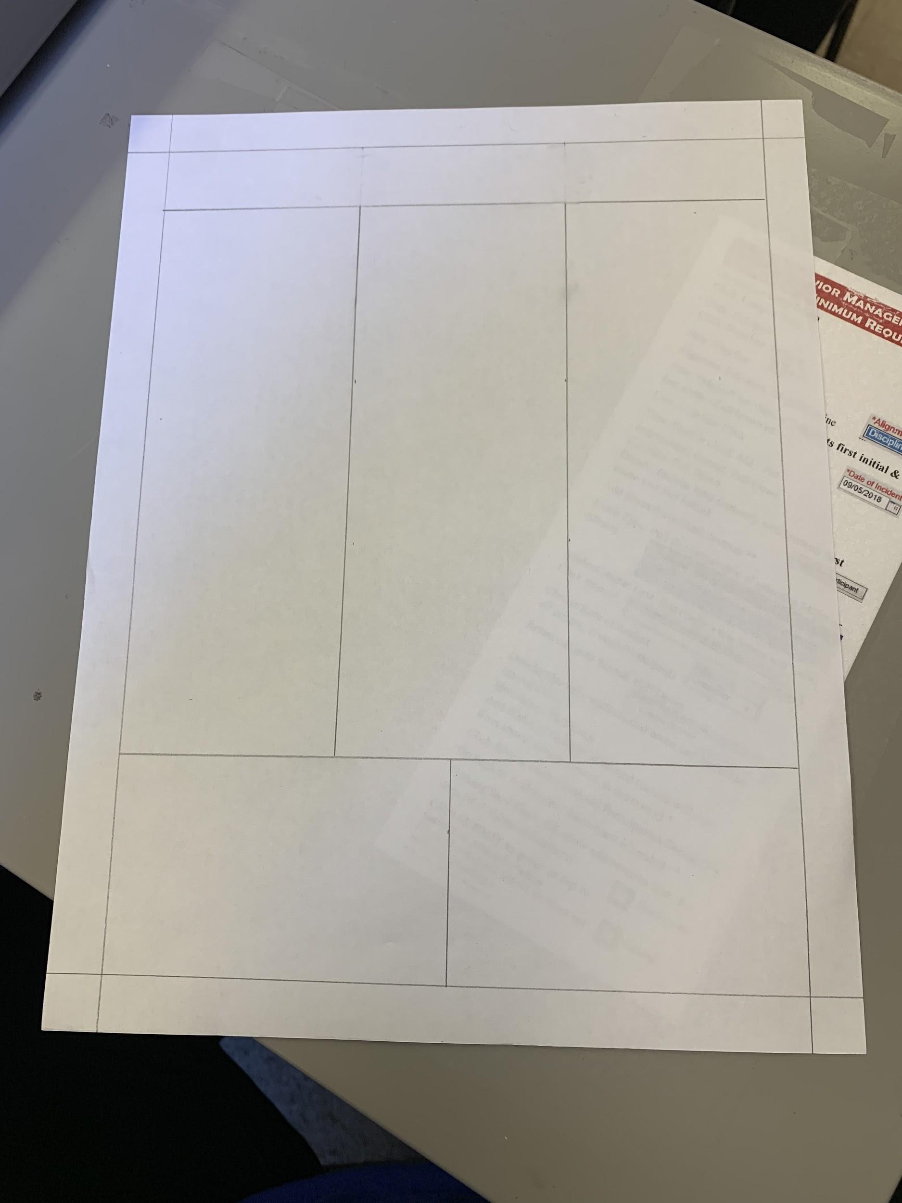
Step 2: Plot out your required elements. Use pencil.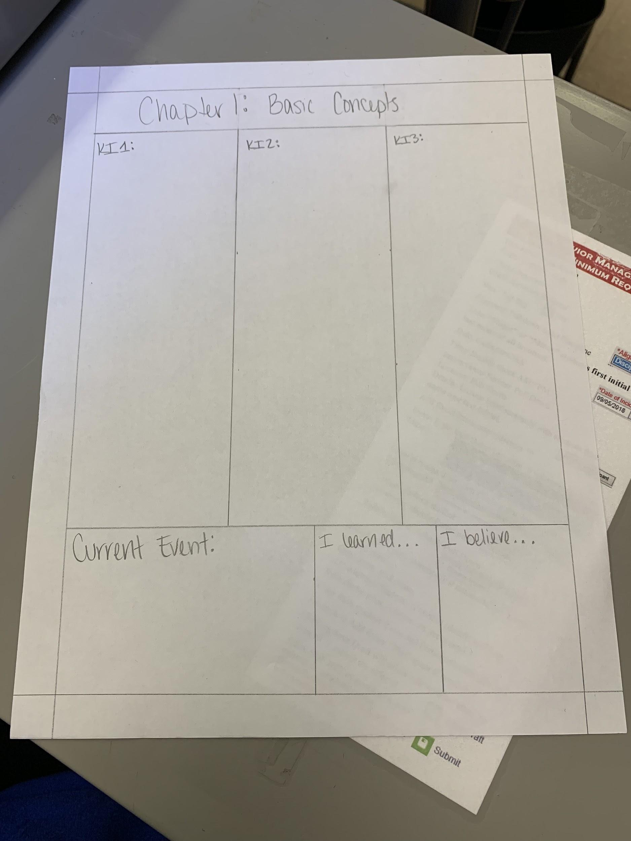
Step 3: Fill in the required content. Use pencil.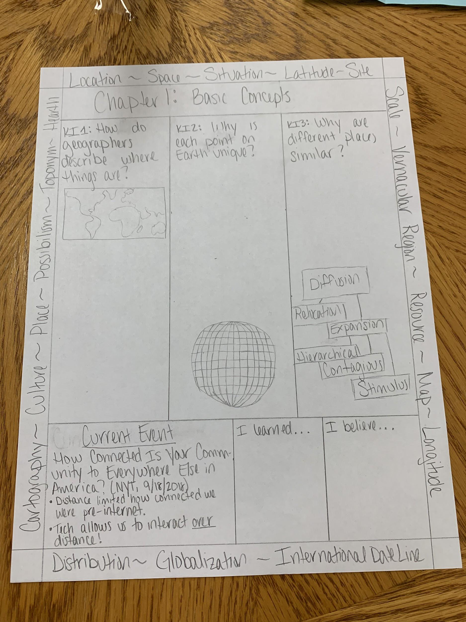
Step 4: Finish filling in the required elements. Use pencil.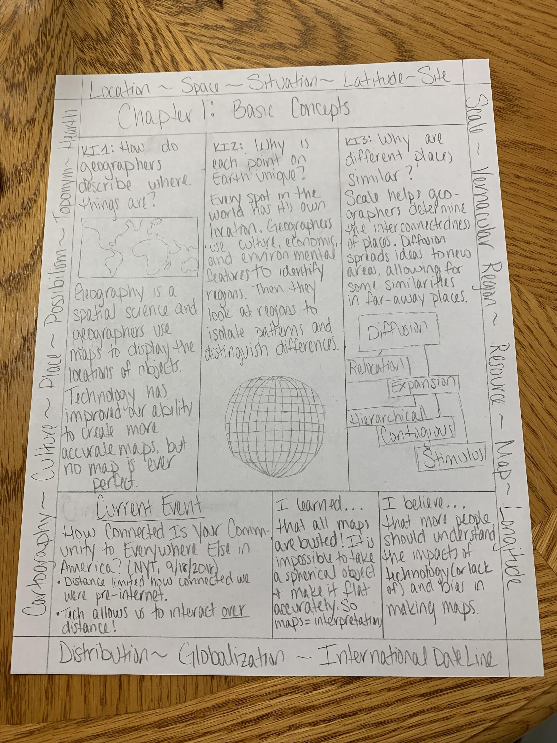
Step 5: Shade in the spaces using colored pencil.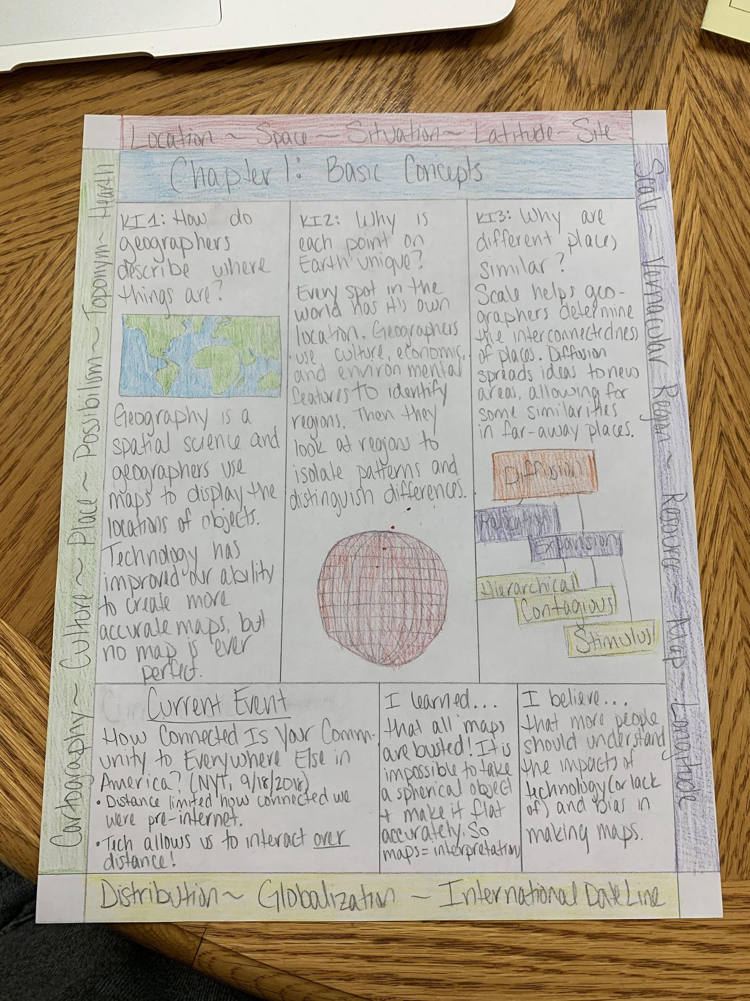
Step 6: Cover up all the remaining pencil. Use ONLY a super sharp colored pencil OR an ULTRA-FINE Sharpie.