[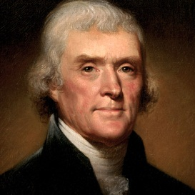](http://www.google.com/url?sa=i&rct=j&q=&esrc=s&frm=1&source=images&cd=&cad=rja&docid=iczpPRyuD-RyuM&tbnid=dcQqs-kqgik1dM:&ved=0CAUQjRw&url=http://www.biography.com/people/thomas-jefferson-9353715&ei=m7w0UrLzIYbW9AS8l4HIAQ&bvm=bv.52164340,d.eWU&psig=AFQjCNH97YNglajUtoOQ_ARsv0X5W4hAzw&ust=1379274259967018)[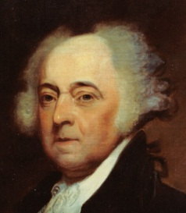](http://www.google.com/url?sa=i&rct=j&q=&esrc=s&frm=1&source=images&cd=&cad=rja&docid=fN-f996AAMU8bM&tbnid=yyRMeFp26QU1LM:&ved=0CAUQjRw&url=http://commons.wikimedia.org/wiki/File:US_Navy-031029-CLOSEUP-N-6236G-001_A_painting_of_President_John_Adams_(1735-1826),_2nd_president_of_the_United_States,_by_Asher_B._Durand_(1767-1845).jpg&ei=Jrw0UobvBZLW9QT88oHwBQ&bvm=bv.52164340,d.eWU&psig=AFQjCNH0iiBIrZ1nvychS_D0L-dVeUop4Q&ust=1379274138441840)[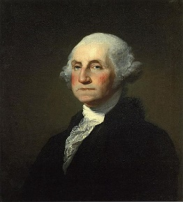](http://upload.wikimedia.org/wikipedia/commons/b/b6/Gilbert_Stuart_Williamstown_Portrait_of_George_Washington.jpg)**Presidential Report Cards…**

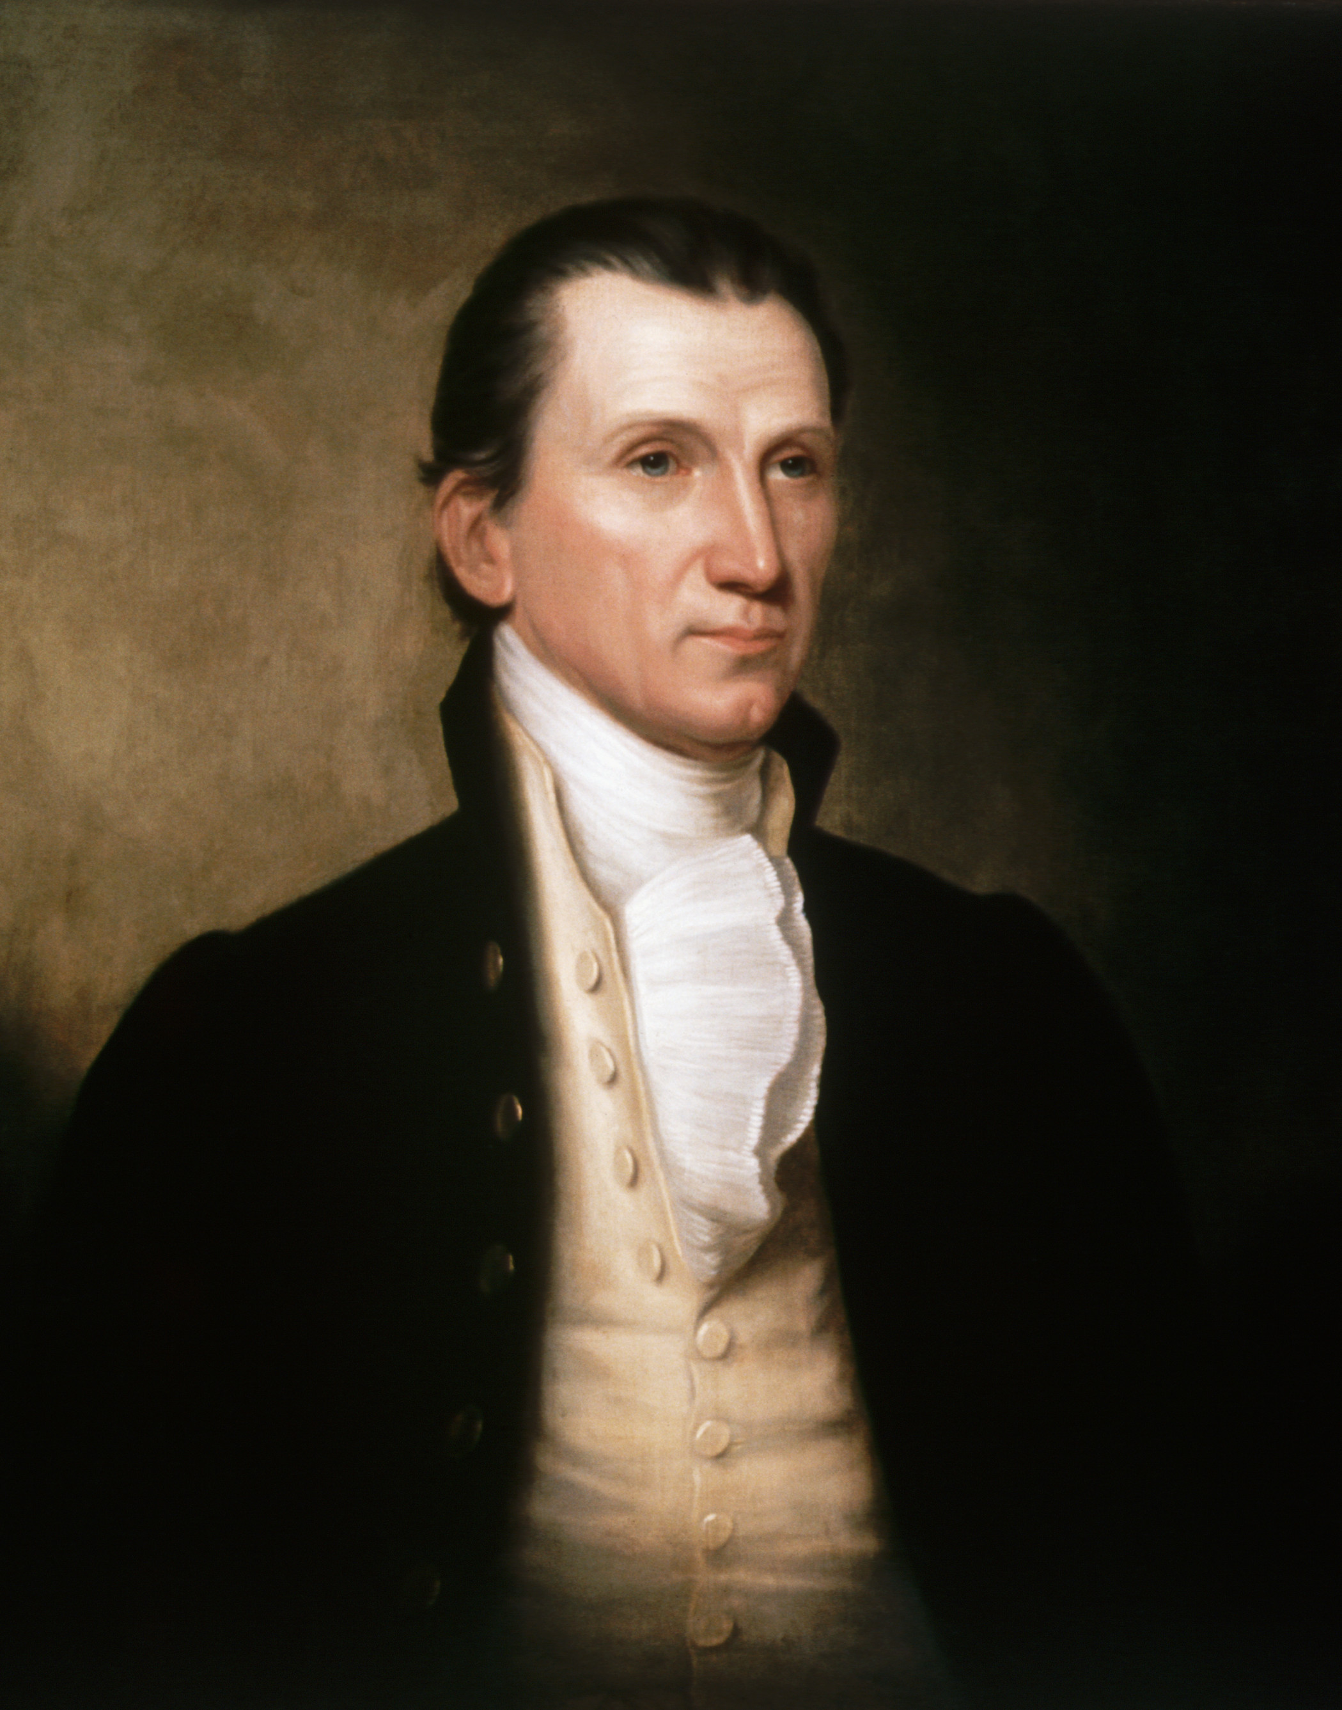



1. George Washington 2. John Adams 3. Thomas Jefferson 4. James Madison 5. James Monroe

**YOUR TASK**  
  
Your task is to research & to evaluate the presidencies of ***George Washington, John Adams, Thomas Jefferson, James Madison, and James Monroe.*** In order to do draw conclusions, you will then assign each president a performance grade (A–F) based on the following:

1. **Whether they met the needs of America as a “*real nation*”**
2. **Whether their actions ultimately helped or hurt America’s development**

Finally, based on your assessment, you will determine which president, ***Washington, Adams, Jefferson, Madison, and Monroe***, demonstrated the best leadership skills and presidential qualities. You will fill out a “report card” in order to grade them.

**Characteristics of a Real Nation** (*did each president contribute to these characteristics?*)

1. Powerful military force
2. Strong economically & a player in the world economic market
3. Political influence over other nations
4. Dominance in foreign affairs & respected throughout the world
5. Freely grants and protects the political & civil rights of its citizens
6. Has a unified government & a common vision of policies for the future
7. Has the respect of its citizens and the ability to control & command that respect

**Assignment Rubric**

|  |  |  |  |  |  |
| --- | --- | --- | --- | --- | --- |
| **Grading Dimensions** | **Exemplary**  **(5)** | **Above Average**  **(4)** | **Average**  **(3)** | **Developing**  **(2)** | **Struggling**  **(1)** |
| **Completed Webquest Questions** | Student completed all questions within the Webquest, using complete sentences; responses were well researched | Student completed a majority of the questions within the Webquest; thoroughly answered and well researched | Student **DID NOT** answer 3 to 4 of the questions within the Webquest; most responses were researched | Student **DID NOT** answer 5 or more questions within the Webquest; responses were not well researched. | Student failed to complete a majority of the questions in the Webquest; responses were not thorough, nor well researched. |
| **Completed Presidential Grading Rubrics** | Student thoroughly completed the entire Presidential Grading Rubric | Student completed the Presidential Grading Rubric and most of it was done thoroughly | Student completed the Presidential Grading Rubric, but it was not done thoroughly | Student was missing a majority of the Presidential Grading Rubric & it was not done thoroughly | Student did not complete the Presidential Grading Rubric |

**George Washington’s Presidency**  
 **Websites to use…**

1. <http://www.mountvernon.org/digital-encyclopedia/article/whiskey-rebellion/>
2. <http://millercenter.org/president/biography/washington-domestic-affairs>
3. <https://www.loc.gov/rr/program/bib/ourdocs/judiciary.html>

**Questions to Answer**

1. What was the ***Judiciary Act of 1789***?

1. What did the Judiciary Act actually establish within the Constitution?
2. How was this an example of checks and balances?
3. What was the ***Whiskey Rebellion***?
4. How did Washington decide to handle the Whiskey Rebellion? What do these actions say about him as a President?

1. How was the Whiskey Rebellion similar and different to Shay’s Rebellion  
   Similar: Different:

**John Adams’ Presidency**

**Websites to use…**

1. <http://avalon.law.yale.edu/subject_menus/alsedact.asp>
2. <http://www.earlyamerica.com/earlyamerica/milestones/sedition>
3. <https://www.monticello.org/site/research-and-collections/xyz-affair>
4. <https://billofrightsinstitute.org/founding-documents/primary-source-documents/virginia-and-kentucky-resolutions/>

**Questions to Answer**

1. What was the ***XYZ Affair***?

1. How did Adams’ handle this incident? What do these actions say about him as a President?
2. How did the XYZ Affair impact the United States’ relationship with France?

1. Summarize the ***Alien and Sedition Acts***.
2. How did Adam’s respond to these acts & how do his actions reflect on him as a President?
3. What were the Virginia and Kentucky Resolutions?

**Thomas Jefferson’s Presidency**  
**Websites to use…**

1. <https://www.monticello.org/site/jefferson/louisiana-purchase>
2. <https://www.britannica.com/topic/Embargo-Act>

**Questions to Answer**

1. What was the ***Louisiana Purchase***? How was Jefferson involved? How do his actions reflect on him as a President?  
   How much did the government buy this land for?
2. What was the ***Embargo Act of 1807***? How did Jefferson handle this? Was it successful? What do his actions say about him as a President?
3. Describe the incident that Jefferson had to deal with regarding the ***Barbary Pirates***. What does this incident demonstrate about Jefferson’s presidency?

**James Madison’s Presidency**

**Websites to use.**

<http://www.history.com/topics/war-of-1812>  
<http://mrnussbaum.com/causes-and-effects-of-the-war-of-1812/>  
<http://www.teenink.com/nonfiction/all/article/156250/Relations-between-Great-Britain-and-the-United-States-between-1777-and-1900/>

**Questions to be answered**

1. What does the word **impressment** mean in **regards** to the War of 1812?
2. How did the War of 1812 help boost American Nationalism?
3. Why is this war important in terms of America’s relationship with Great Britain?
4. Who was considered a war hero at the Battle of New Orleans (and would later become President)

**James Monroe’s Presidency**

**Websites to Use:  
1.** [**http://www.u-s-history.com/pages/h278.html**](http://www.u-s-history.com/pages/h278.html) **2.** [**http://www.history.com/topics/monroe-doctrine**](http://www.history.com/topics/monroe-doctrine)

**Questions to answer:**1. What was the American System?

2. Was the American System a good thing or bad thing? Explain your answer.

3. What did the Monroe Doctrine say to the other European Powers (as far as their involvement in the Western Hemisphere)?

4. Was the Monroe Doctrine a good thing for the U.S? Explain your answer.

**Presidential Report Cards…**

|  |  |  |  |
| --- | --- | --- | --- |
| **GEORGE WASHINGTON** | **Help** or **Hurt** the development of the United States? | **Why?** | **George Washington’s Letter Grade + justification for grade** |
| **Judiciary Act of 1789** |  |  |
| **The Whiskey Rebellion** |  |  |

|  |  |  |  |
| --- | --- | --- | --- |
| **JOHN ADAMS** | **Help** or **Hurt** the development of the United States? | **Why?** | **John Adams’ Letter Grade + justification for grade** |
| **The XYZ Affair** |  |  |
| **The Alien & Sedition Acts** |  |  |
| **Virginia and Kentucky Resolutions** |  |  |
| **THOMAS JEFFERSON** | **Help** or **Hurt** the development of the United States? | **Why?** | **Thomas Jefferson’s Letter Grade + justification for grade** |
| **Barbary Pirates** |  |  |
| **Louisiana Purchase** |  |  |
| **Embargo Act of 1807** |  |  |

|  |  |  |  |
| --- | --- | --- | --- |
| **James Madison** | **Help** or **Hurt** the development of the United States? | **Why?** | **James Madison’s Letter Grade + justification for grade** |
| **War of 1812** |  |  |

|  |  |  |  |
| --- | --- | --- | --- |
| **James Monroe** | **Help** or **Hurt** the development of the United States? | **Why?** | **James Monroe’s Letter Grade + justification for grade** |
| **American System** |  |  |
| **Monroe Doctrine** |  |  |