(pre-modern) (urban/industrial) (mature industrial) (post industrial) (declining?)
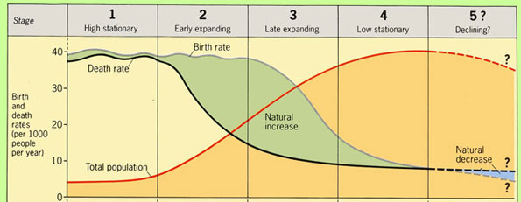

Stage 1 - High Stationary:
Pre-Industrial (have not undergone industrialization), largely agricultural groups (primary sector dominant)
Defining characteristics: High CBR, high CDR, low/no NIR, low overall population numbers
Reasons for high CBR
- High IMR. When families are not confident their children will survive, they have typically had more children so that some survive to adulthood.
- Lack of family planning. Contraceptives are designed to prevent pregnancy. Therefore, in areas where contraceptives are not readily available or not socially acceptable, birth rates will be higher.
- Children are economic assets. They will work in the fields & support parents as they get older.
- Historically, certain cultural/religious groups have had larger families (Hindus, Catholics, Muslims). This is not necessarily true any more.
Reasons for high CDR
- Disease, famine, war will all lead to high (although inconsistently high) death rates.
- Poor hygiene & sanitation. This leads to higher CDR, IMR, CMR, and lower life expectancy. The World Bank estimates that 2.4 billion people still lack access to a toilet. November 19 is World Toilet Day.
- Lack of healthcare. This can be measured by numbers of doctors and hospital beds. This is still particularly an issue in rural (largely agricultural) areas.

Stage 2: Early Expanding
Industrializing (BEGINNING to industrialize), still largely agricultural, but new labor saving technology is emerging (rising secondary sector)
Corresponds with periphery countries
Defining characteristics: High CBR, rapidly declining CDR, high NIR (highest NIR is in stage 2)
Reasons for high CBR
- Same reasons as stage 1. Remember the CBR doesn't increase, it just REMAINS HIGH
Reasons for rapidly declining CDR
- Improved healthcare, drinking water & sanitation. As countries underwent the Industrial Revolution, healthcare, drinking water quality and sanitary conditions gradually increased over decades.
- Improved food production. One of the major changes with the Industrial Revolution was improvements in agricultural production, which was able to support additional people.
- Decreasing IMR. As Infant Mortality Rates decline, this also means fewer overall deaths.
- Outside stimulus. Many MDCs have provided medical assistance and foreign investment in LDCs. This has led to improvements in life expectancy, decreases in infant & child mortality rate, as well as crude death rates.

Stage 3: Late Expanding
Industrialized (has undergone industrialization), large factory workforce (secondary sector)
Corresponds with semiperiphery countries
Defining characteristics: Declining CBR, declining CDR, NIR increasing more slowly ("growing but slowing")
Reasons for declining CBR
- Changing status of women. As countries industrialize and become more developed, gender equality generally increases. As women gain access to education and employment, the number of children per woman typically decreases.
- Lower IMR. As families become more confident that each child born will grow to adulthood, families will have fewer children.
- Labor-saving technology. As countries industrialize, the need for workers decreases as labor saving technology is introduced. This reduces the need for bigger families.
- Welfare/Retirement. With the introduction of government welfare, assistances, and retirement programs, like Medicare and Social Security in the U.S., elderly citizens do not need children to provide for them. This in turn can lead to lower fertility rates.
- Increasing urbanization. As people leave the farms (rural) to work in factories (urban), demographics change. Cities have higher population densities & concentrations, therefore, families tend to be smaller because it is more expensive to have a big family in the city.
- Availability of family planning. As families gain access to family planning (i.e. planning number of children, birth spacing, contraception, voluntary sterilization), the number of children per woman is generally lower.
Reasons for declining CDR
- Same reasons as stage 2. The CDR is still declining but at a slower rate than stage 2

Stage 4 - Low Stationary
Post-industrial society, large labor market based on the provision of services (tertiary is dominant, while secondary and primary are stagnant or declining).
Corresponds with core countries
Defining characteristics: Low CBR, low CDR, low/no NIR, high total population
Reasons for low CBR
- Same reasons as stage 3. The CBR has declined to a low overall level.
Reasons for low CDR
- Same reasons as stages 2 & 3. The CDR has declined to a low overall level.

