AP HUG
Unit IV Political Patterns and Processes
Choke Points

Introduction: There are approximately 200 straits (narrow bodies of water connecting two larger bodies of water) or canals around the world but only a handful are known as chokepoints. A chokepoint is a strategic strait or canal which could be closed or blocked to stop sea traffic (especially oil). This type of aggression could surely cause an international incident.

Objective: I can describe the concepts of political power and territoriality as used by geographers.
- Political power is expressed geographically as control over people, land, and resources, as illustrated by neocolonialism, shatterbelts, and choke points.

Directions: Analyze the graphics/maps, and read through the information/case studies below, then answer the questions provided.

UNCLOS - Transit Passage Through International Straits
The United Nations Convention on the Law of the Sea (UNCLOS) enshrines the concept of innocent passage through a coastal State’s territorial sea. Passage is innocent so long as it is not prejudicial to the peace, good order or security of the coastal state. A vessel in innocent passage may traverse the coastal state’s territorial sea continuously and expeditiously, not stopping or anchoring except in force majeure situations. The right of “transit passage through international straits,” as defined in the Convention, is nonsuspendable and applies to all vessels – military and commercial – and also to airplanes. Submarines are allowed to remain submerged when they exercise the right of transit passage.  Military and commercial vessels alike always enjoy the right of innocent passage and self-defense while within the territorial sea of a foreign state, granted they do not undertake activities which can be interpreted as a threat to the coastal state or engage in the use of force against the coastal state, including the “launching, landing, or taking aboard any aircraft or military device,” per Article 19 (2) (f) of UNCLOS. | According to Article 19 (2) of UNCLOS, passage of a foreign ship shall be considered prejudicial to the peace, good order or security of the coastal state and thus in non-innocent passage if, in the territorial sea (less than 12 nautical miles from shore), it engages in any of the following activities:  (a) any threat or use of force against the sovereignty, territorial integrity or political independence of the coastal State, or in any other manner in violation of the principles of international law embodied in the Charter of the United Nations;  (b) any exercise or practice with weapons of any kind;  (c) any act aimed at collecting information to the prejudice of the defence or security of the coastal State;  (d) any act of propaganda aimed at affecting the defence or security of the coastal State;  (e) the launching, landing or taking on board of any aircraft;  (f) the launching, landing or taking on board of any military device;  (g) the loading or unloading of any commodity, currency or person contrary to the customs, fiscal, immigration or sanitary laws and regulations of the coastal State;  (h) any act of wilful and serious pollution contrary to this Convention;  (i) any fishing activities;  (j) the carrying out of research or survey activities;  (k) any act aimed at interfering with any systems of communication or any other facilities or installations of the coastal State;  (l) any other activity not having a direct bearing on passage.

After reading through UNCLOS Innocent and Transit Passage (not all UN Member States have signed or ratified the treaty):
- How could this Negatively affect States?

- How could this Positively affect States?

- Explain one “non-innocent passage” you consider least important. Why?

- Explain one “non-innocent passage” you consider most important. Why?

The Strait of Hormuz
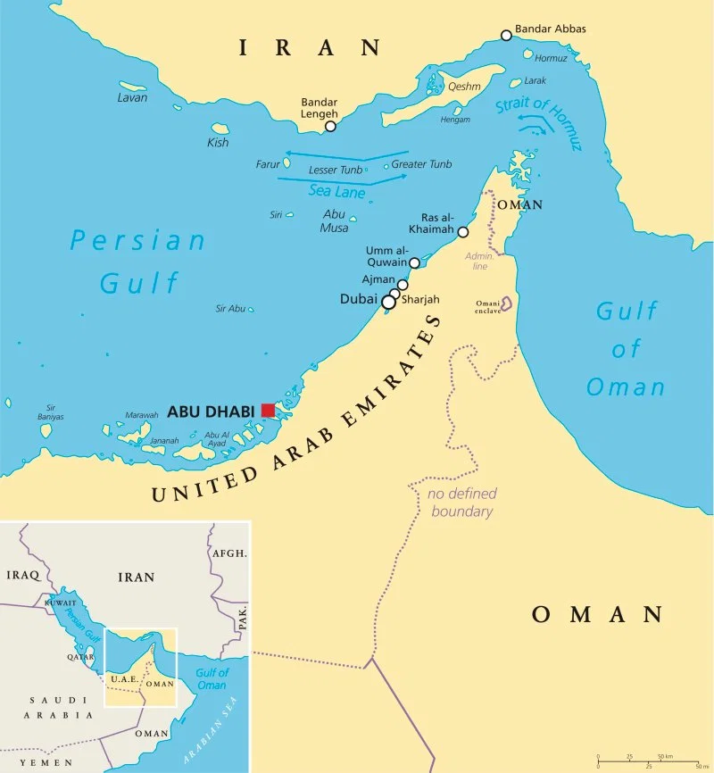 | The Strait of Hormuz is a narrow waterway that links the Persian Gulf with the Gulf of Oman and the Arabian Sea. At its narrowest point, the waterway is only 21 miles wide, and the width of the shipping lane in either direction is just 2 miles, separated by a 2-mile buffer zone.  Oil tankers carrying crude from ports on the Persian Gulf must pass through the strait. Around 21 million barrels of oil a day flowed through it in 2018, equivalent to roughly a third of global seaborne oil trade and about 21% of global petroleum liquids consumption.

After viewing the map and reading about The Strait of Hormuz:
- Which countries hold the strait within their Territorial Waters?

- What is at stake if these countries do not uphold the laws established in UNCLOS?

Strait of Malacca
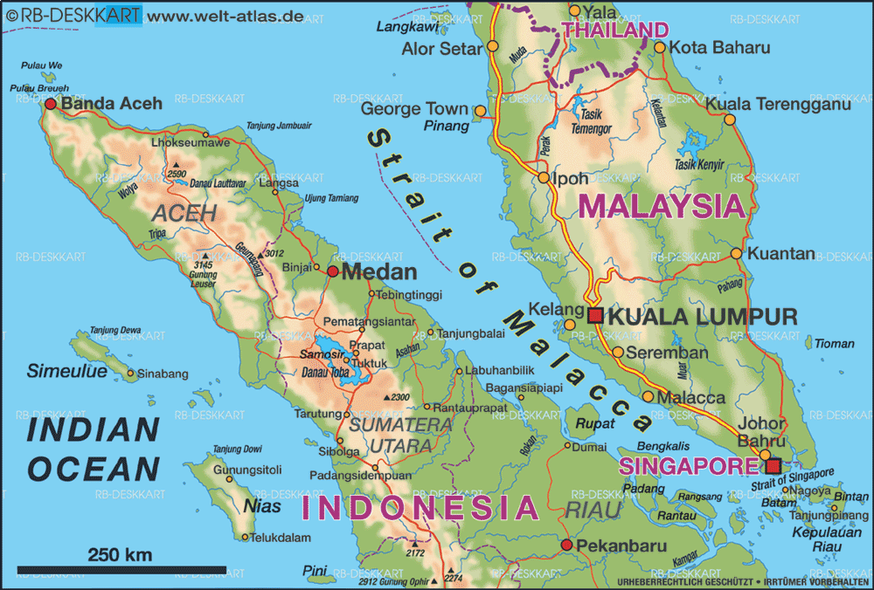  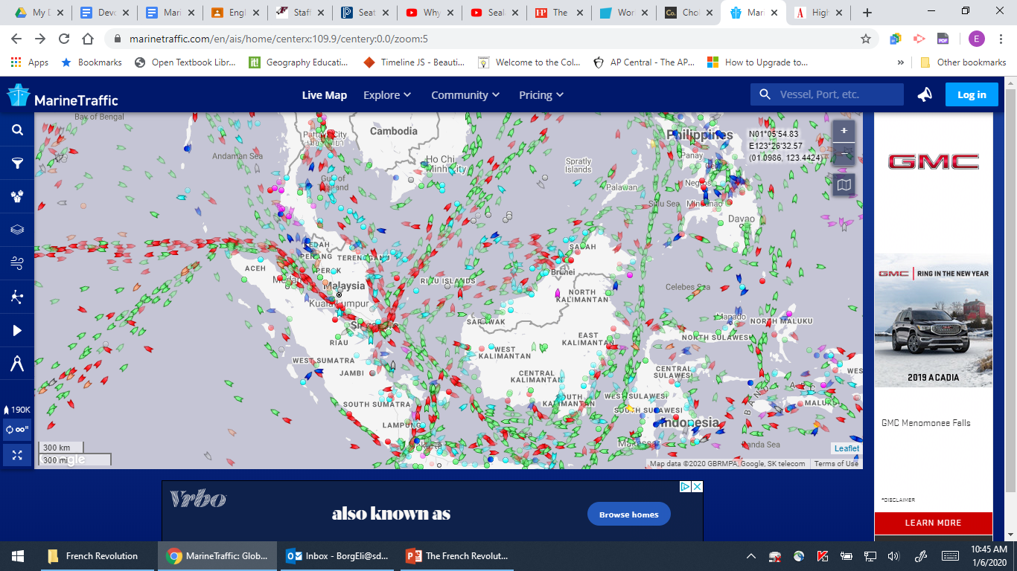 | This is the shortest passageway, connecting the Indian Ocean to the South China Sea and the Pacific Ocean. This route supplies oil to China and Indonesia, two of the fastest growing economies in the world, and is the primary choke point in Asia. Some 16 million b/d flowed through here in 2016, making it the second most important energy passageway.  The Strait of Malacca has strategic importance, too: China, the dominant Asian power, is heavily reliant on the Middle East for its energy needs; about 25 percent of oil shipped between the Middle East and Asia passes through the strait—a figure that has steadily increased as China and other regional powers grow in population and wealth. Any blockade of the strait would result not only in China being cut off from its energy supplies in the Middle East, but also from raw material from Africa, where China has invested billions of dollars in mining and infrastructure projects.  The Strait of Malacca is among the most narrow chokepoints in the world, measuring only 1.7 miles at its widest point. “If the Strait of Malacca were blocked, nearly half of the world’s fleet would be required to reroute around the Indonesian archipelago,” the EIA said. “Rerouting would tie up global shipping capacity, add to shipping costs, and potentially affect energy prices.”

After viewing the map and reading about The Strait of Malacca:
- Which countries hold the strait within their Territorial Waters?

- What is at stake if these countries do not uphold the laws established in UNCLOS?

Suez Canal
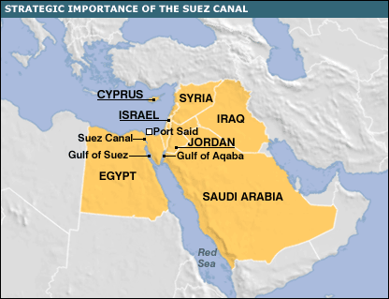 | The 103 mile long Suez Canal is located entirely within Egypt and it is the only sea route between the Red Sea and the Mediterranean Sea. With Middle East tension, the Suez Canal is a prime target for many nations. The canal was completed in 1869 by French diplomat Ferdinand de Lesseps. The British took control of the canal and Egypt from 1882 until 1922. Egypt nationalized the canal in 1956. During the Six-Day War in 1967, Israel seized control of the Sinai Desert directly east of the canal but relinquished control in exchange for peace.  This passageway accounted for about 9 percent of the world’s maritime oil trade in 2015 or 5.5 million b/d.

After viewing the map and reading about The Suez Canal:
- Which countries hold the strait within their Territorial Waters?

- What is at stake if these countries do not uphold the laws established in UNCLOS?

Bab el-Mandeb Strait
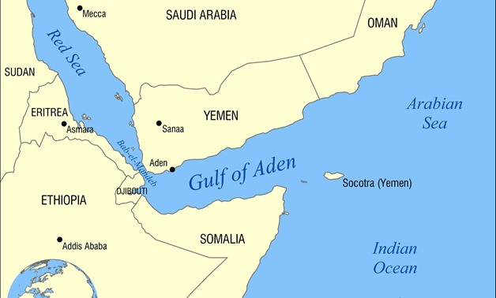 | The Bab el-Mandeb strait is a strategic waterway located between Djibouti and Yemen that links the Red Sea to the Indian Ocean. At its narrowest, it is only 18 miles across. Exports from the Persian Gulf and Asia destined for Western markets must pass through the strait before passing through the Suez Canal. It is also perhaps the most dangerous and geo-politically contested strait in the world.  The civil war in Yemen and the border dispute between Eritrea and Djibouti means that constant conflict surrounds the strait. In recent years the United States, the North Atlantic Treaty Organization, and the European Union have all conducted counter-terrorism and counter-piracy operations in the region. Furthermore, the Americans, Chinese, Germans, French, Qataris, Emiratis, Saudi Arabians, Japanese, and Italians all have some form of military presence near the Bab el-Mandeb.  If the Bab el-Mandeb Strait were closed, it could keep tankers in the Persian Gulf from reaching the Suez Canal, diverting them around the Cape of Good Hope, another of the world’s chokepoints. An estimated 4.8 million b/d flow through this strait en route to Europe, the United States and Asia.

After viewing the map and reading about the Bab el-Mandeb Strait:
- Which countries hold the strait within their Territorial Waters?

- What is at stake if these countries do not uphold the laws established in UNCLOS?

