FRQ #1 – 25 Mins

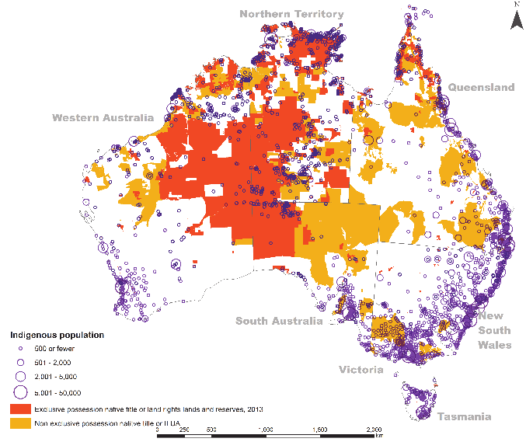

- Identify the map type that is used to illustrate the amount of indigenous population by number.
- Compare reference maps and thematic maps.
- Describe the spatial distribution for indigenous Australians in Map A.
- Describe the relationship between the location of exclusive and non-exclusive possessions of native lands and the distribution of Australia’s indigenous populations.
- Explain why using relative distances and directions can be useful when interpreting geospatial data.

FRQ #2- 15 mins

Cell Tower Coverage
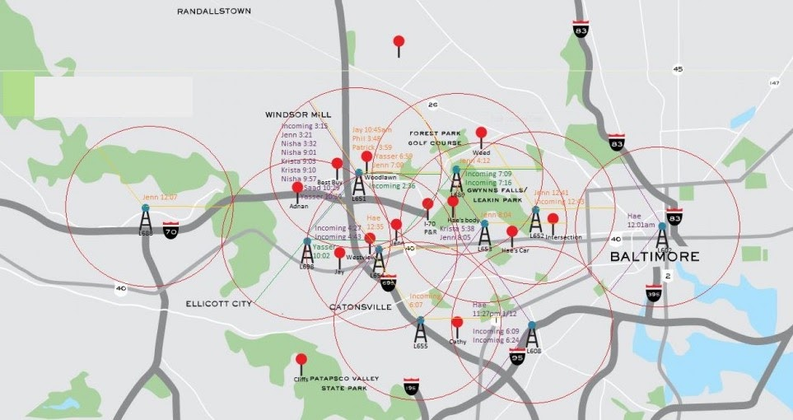

- Define region.
- Identify whether the image portrays an example of a formal, functional, or vernacular region.
- Explain why using a regional approach to measuring internet connectivity is more beneficial than using political borders.
Compare the ways in which a regional analysis can be used when investigating the existence of a digital divide at various scales.

