Name:__________________________

Unit 5 Notes & Study Guide
Agriculture, Food Production and Rural Land Use Ch 9

Unit V – Agriculture & Rural Land-Use Patterns and Processes

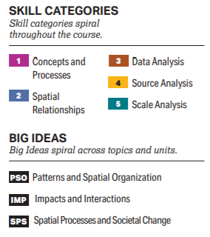 | 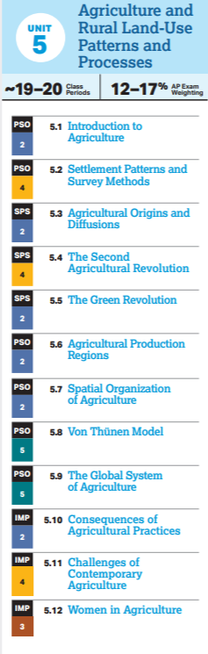

Topic 5.1 Introduction to Agriculture | Topic 5.2 Settlement Patterns & Survey Methods
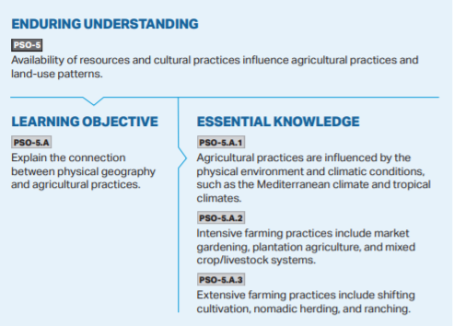 | 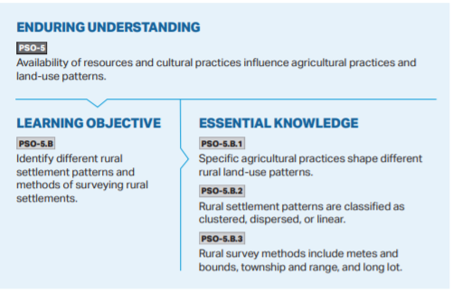
Topic 5.3 Agricultural Origins & Diffusions | Topic 5.4 The Second Agricultural Revolution
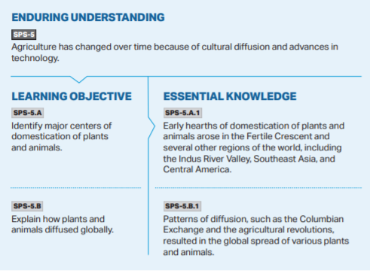 | 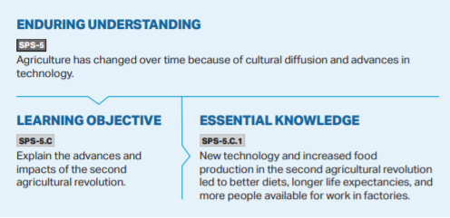
Topic 5.5 The Green Revolution | Topic 5.6 Agricultural Production Regions
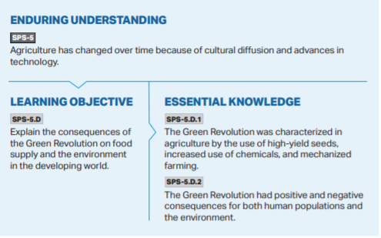 | 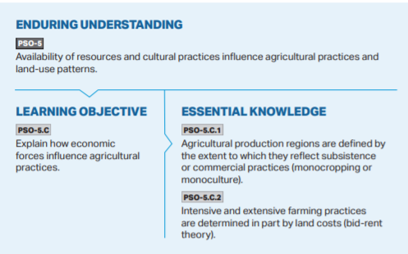
Topic 5.7 Spatial Organization of Agriculture | Topic 5.8 Von Thunen Model
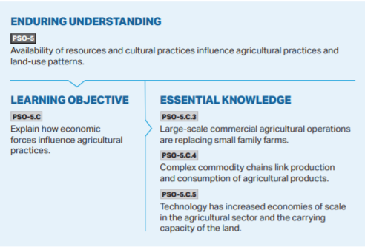 | 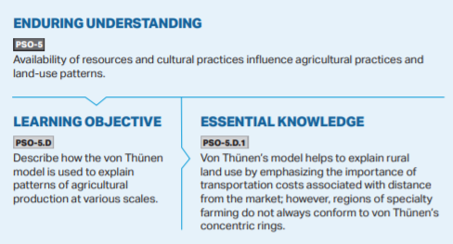
Topic 5.9 The Global System of Agriculture | Topic 5.10 Consequences of Agricultural Practices
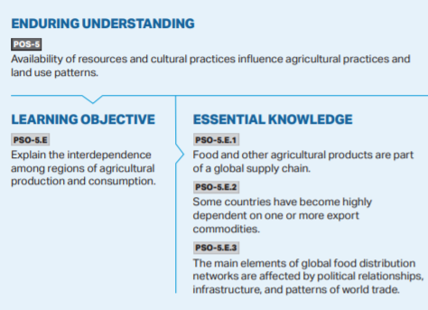 | 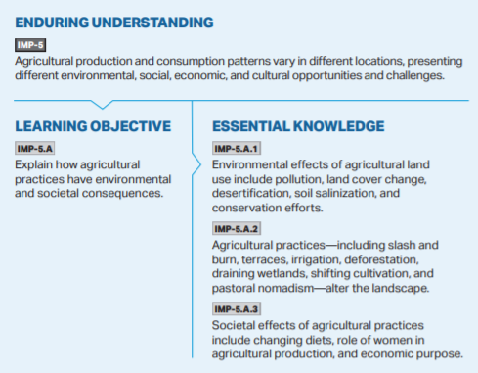
Topic 5.11 Challenges of Contemporary Agriculture | Topic 5.12 Women in Agriculture
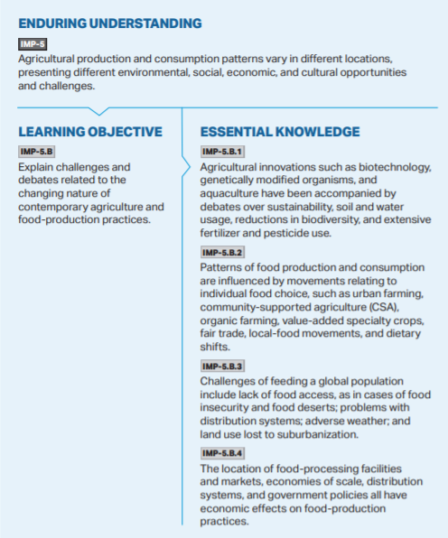 | 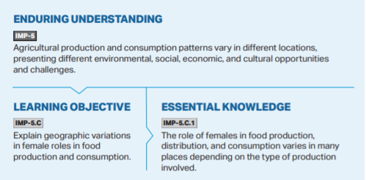

Chapter 9 Food & Agriculture
Chapter 9 Key Issue 9.1: Why Do People Consume Different Foods?
Rubenstein Pages 312-317
**It is essential that you read the chapters thoroughly and not just look for the answers. You will be accountable for all the material in the chapter, even if it is not in the questions.

Food, Agriculture, & Geography
- What three factors impact the variation of diet around the world? Explain each
*
*
*
- Define dietary energy consumption.

3. Analyze the Dietary Energy Consumption 2013 Map and read the “Total consumption of Food” section and identify 3 key details regarding food consumption around the world.
*
*
*
Global Agriculture & Undernourishment
4. Define food security:
IMP 5.B.3

5. How much of the world does not have food security? ________________

6. Define undernourishment:

7. How much of the world suffers from undernourishment? Where are those places?

Food Prices
8. Describe the differences in food prices in Developed vs Developing regions
Developed Regions | Developing Regions

9. What 4 factors impact food prices the most?

Source of Nutrients
10. Define cereal grain:

11. Define grain:

12. Three grains account for 90% of all dietary energy consumed world-wide (Identify then and take notes on each. Make sure to be familiar with corresponding regions)

13. Compare and contrast the world’s meat consumption. Where is most meat consumed? Where is the least meat consumed? Why? Explain.

Chapter 9 Key Issue 9.2: Where Did Agriculture Originate?
Rubenstein Pages 318-321

Invention of Agriculture
1. Define agriculture:

2. Define crop:

3. What are the characteristics of a hunter-gatherer society?

4. How many hunter-gatherers are there today?

5. Where are current hunter-gatherer societies found today?

6. What was the agricultural revolution?

7. Explain the environmental and cultural factors that contributed to the agricultural revolution.

8. Agricultural Hearths - Identify (shade & label) the five agricultural hearths. For each, identify key cultivated crops and domesticated animals along with key dates. Additionally, make a timeline across the bottom and put key developments in chronological order. (Focus on crops/animals mentioned in the reading—you do not have to include everything in Figure 9-19)
SPS 5.A.1

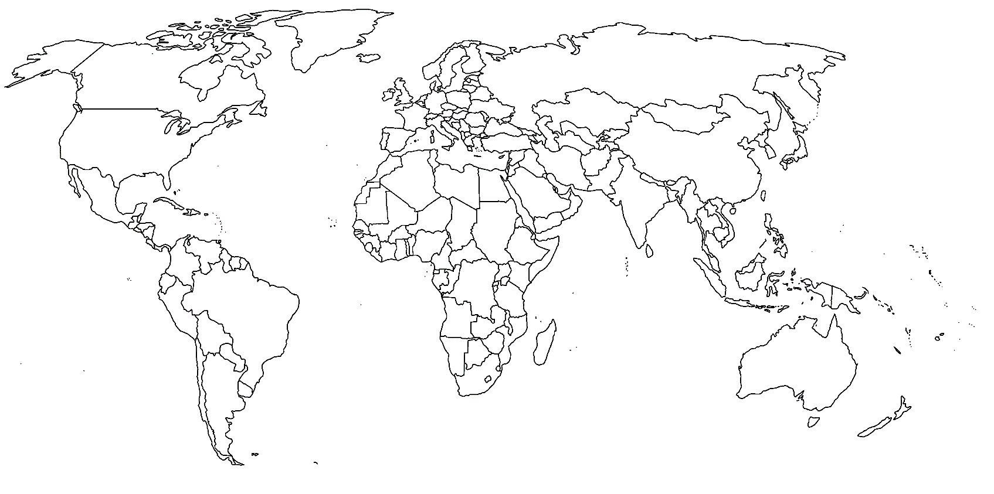

9. The fact that agriculture has multiple hearths means that . . .

10. Define the Columbian Exchange and explain how it impacted the movement of plants and animals from their hearths:
SPS 5.B.1

SUBSISTANCE & COMMERCIAL AGRICULTURE
11. Define subsistence agriculture:
PSO 5.C.1

12. Define commercial agriculture:

Read pgs. 320-321 and complete the chart below with important information. The text will generally explain commercial agriculture, and you will need to deduce the situation of subsistence agriculture on your own.
 | Subsistence Agriculture  (Mostly in LDCs) | Commercial Agriculture  (Mostly in MDCs)
% of Farmers in Labor Force (and why)
Use of Machinery, Science, & Technology
Farm Size
Relationship of farming to other businesses.

Chapter 9 Key Issue 9.3: Where is Agriculture Distributed?
Rubenstein Pages 322-337

Agricultural Regions
1. Geographer _________________________________ (1936) created an agricultural map of the
world that is still widely used today. His map contained 11 agricultural zones:

- 5 are found among developing countries: - 6 are found among developed countries:
pastoral nomadism mixed crop & livestock
shifting cultivation dairy
intensive subsistence, wet rice dominant grain
intensive subsistence, wet rice not dominant livestock ranching
plantation Mediterranean
commercial gardening

For each type of agriculture, note where it is practiced geographically and what climate region(s) support that type of agriculture. (climate region map is found on page 36 and page 329)
Subsistence Agriculture
PSO 5.A.1
5.A.2
5.A.3
 | Where It’s Practiced | Climate Region
Pastoral Nomadism

Shifting Cultivation

Intensive Subsistence – Wet rice dominant

Intensive Subsistence- other than wet rice

Plantation (sometimes seen as commercial)

Commercial Agriculture
 | Where It’s Practiced | Climate Region
Mixed crop and livestock

Dairying

Grain

Ranching

Mediterranean

Commercial Gardening

Subsistence Agriculture in Population Concentrations
2. INTENSIVE SUBSISTANCE WITH WET RICE NOT DOMINANT
In a bulleted list, explain the process of the above Ag Region
Define Intensive Subsistence Agriculture
Describe the attributes of
IS-WRND
Define double cropping
Define crop rotation

3. INTENSIVE SUBSISTENCE WITH WET RICE DOMINANT
Describe the characteristics of IS-WRD
Describe the cultivation of wet rice | *Field Prep:  *Flooding—define sawah & paddy  *Transplanting  *Harvesting

4. SHIFTING CULTIVATION
In a bulleted list, explain the process of the above Ag Region
Define Shifting Cultivation
Describe the attributes of Shifting Cultivation
Define slash-and-burn agriculture
Process of Shifting Cultivation
Crops of Shifting Cultivation
Ownership and use of land in Shifting Cultivation

Future of Shifting Cultivation

5. PASTORAL NOMADISM
In a bulleted list, explain the process of the above Ag Region
Define Pastoral Nomadism
Describe the attributes of Pastoral Nomadism
Choice of animals
Movements of pastoral nomads
Define transhumance
Define pasture
Future of P.N.

6. PLANTATION
In a bulleted list, explain the process of the above Ag Region
Define Plantation Farming
Describe where it is practiced

Crops grown & Purpose of crops

Plantation is operated and worked by whom?

7. FISHING
- Identify and define the two ways water-based food is acquired:

- Take notes on each of the following practices:

- Fish production -

- Fish consumption -

- Overfishing -

8. COMMERCIAL FARMING IN DEVELOPED COUNTRIES – 6 regions/practices
a. Define agribusiness:
PSO 5.C.3

-Includes a variety of services/enterprises, such as:

b. Define monocropping:

9. (Commercial) GRAIN FARMING

- What is the principal difference between grains common in “commercial grain farming” regions and grains grown in “mixed crop and livestock” regions?

- Identify the three regions of large-scale grain production in North America.

- Identify multiple reasons that show why wheat is an important crop.

- How has the distribution of wheat production changed in the last 50 years?

10. (Commercial) MEDITERRANEAN AGRICULTURE

- Most crops are grown for:

- Located in what regions? Climate factors?

- Define horticulture:

- Key cash crops along the Mediterranean:

- Key cash crops in California:

11. COMMERCIAL GARDENING & FRUIT FARMING (also called Truck Farming)

- Located in what regions? Climate factors?

- Types of crops:

- Sold to?

- What is specialty farming? Located?

12. (Commercial) LIVESTOCK RANCHING

- Define ranching:

- Located where and why?

- Growth in ranching has occurred where recently? Examples?

- How has ranching changed in the U.S. in recent years? Why?

- What animals are ranched commonly around the world other than cattle?

13. (Commercial) DAIRY

- Located where and why?

- Define milkshed:

- Why do some regions specialize in milk products such as cheese and butter rather than fluid milk? Identify some of these important regions.

- What country is the world’s largest per capita producer of dairy products?

Define per capita -

- What challenges do dairy farmers currently face?

14. MIXED CROP AND LIVESTOCK
In a bulleted list, explain the process of the above Ag Region
Define mixed crop and livestock
Integration of Crops and Livestock
U.S. Corn Belt location

Different ways corn and soybeans are used
Define fallow and describe how it relates to crop rotation (You will have to look for this on the internet)

15. IMPORTANCE OF ACCESS TO MARKETS
  - Who was von Thunen?
PSO 5.D.1
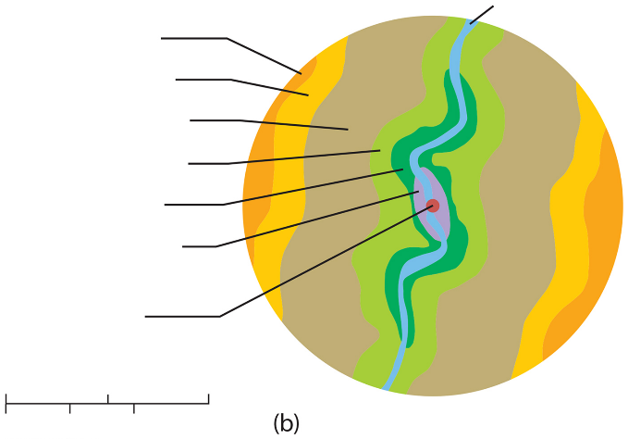
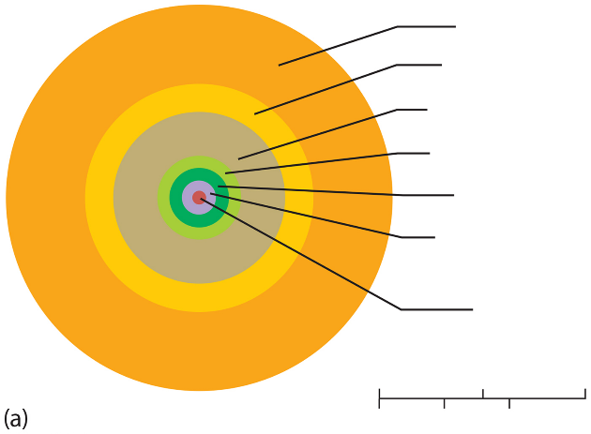
The von Thünen Model (Label the models below.)
(Johann Heinrich von Thünen, 1826)

- Applies to __________________ farming because…

- Key concepts:
  - Describes the relationship between what
two factors/decisions a farmer makes?

  - In making their choices, farmers compare what two costs?

  - Identify/describe each of the model’s rings:

    - First ring:

    - Second ring:

    - Third ring:

    - Fourth ring:

Chapter 9 Key Issue 9.4: Why Do Farmers Face Sustainability Challenges?
Rubenstein Pages 338-349

1. GLOBAL FOOD TRADE
a. Describe the evolution of global food trade
PSO 5.E.1

b. Analyze Figure 9-53. What factors might explain why the UK and Japan are net importers of food?

c. Farmers and governments in LCDs must decide whether to produce export crops or crops for domestic
production. Why is this a dilemma?

d. In what ways is agriculture in LCDs “gendered work”?

2. DRUGS TRADE
Some LDCs turn to the production of drug crops for export. The geography of these crops is distinctive. Identify the countries associated with the crops below.
Cocaine (Cocoa Leaf)
Heroin (Opium)
Marijuana

3. LOSING AGRICULTURAL LAND

a. Historically, increases in world food production were due to ________________________________.

b. Two causes of loss of farmland include:

c. Where in the U.S. is loss of farmland to urbanization especially severe?

d. What human actions contribute to desertification (also called semiarid land degradation)?

e. Ironically, excessive water in semi-arid lands can be problematic—how/why?

4. IMPROVING AGRICULTURAL PRODUCTIVITY

a. During the second half of the 20th century, the world population ___________________ but the

amount of farmland ________________________. Yet, food production has __________________.

b. Describe second agricultural revolution.

c. Ester Boserup argued that a growing population will influence demand for food and lead to

increased food production. Her argument directly contradicted ___________________’ argument (not found in this section, but you’ve studied this!).

d. Boserup argued that subsistence farmers could increase the supply of food through intensification of production in two ways:

e. Define multi-cropping:

f. The Green Revolution, which began during the 1970s and 1980s, involves what two main practices?
SPS 5.D.1
5.D.2

g. How has the Green Revolution influenced the food production-population dynamic?

h. Describe the characteristics of the “miracle wheat seed” and the “miracle rice seed.”

i. What specific problems do farmers in LDCs have that might prevent them from taking full advantage of the Green Revolution?

5. APPLYING BIOTECHNOLOGY TO AGRICULTURE

a. Define a genetically modified organism (GMO):

b. How is a GMO different from selective reproduction?

c. What are “Round-up ready” seeds?

d. Describe the extent of GMO crops throughout the USA:
Amount of Farmland

Specific Crops

Amount of Food

e. Describe the arguments against GMO’s
Health Problems

Export Problems

Increased Dependence on the USA

f. What regions of the world do and don’t require labeling of GMOs?

g. Do you think GMO products should be labeled? Why or why not?

6. SUSTAINABLE FARMING

a. In developed countries, demand for food has remained __________________ due to

_______________________; however, there has been rapid demand increases for

_______________ and _________________ food.

b. _____________________ is the leader in organic farming. Other leading countries include:

c. What are some characteristics of organic farming?

d. Critics of confined livestock production systems point out that such systems are not sustainable. Why?

e. In the U.S., the livestock are often fed antibiotics—why?

7. SUSTAINABLE LAND MANAGEMENT

a. Define conservation tillage:

b. Define no tillage:

c. Define ridge tillage:

8. CONSERVING AGRICULTURAL RESOURCES

a. Describe the agricultural production and water usage in California.

b. What problems does California face regarding sustainability?

c. Identify the three U.S. government policies aimed at improving farmers’ lives:

d. Compare farm subsidies in the U.S. and Europe.

e. Identify criticisms of farm subsidies:

