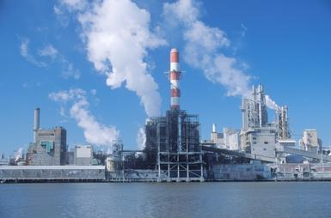
Development Theories in Geography
Geographers often seek to categorize places using a scale of development, frequently dividing nations into the "developed" and "developing," "first world" and "third world," or "core" and "periphery." All of these labels are based off of judging a country's development, but this raises the question: what exactly does it mean to be "developed," and why have some countries developed while others have not? Since the beginning of the twentieth century, geographers and those involved with the vast field of Development Studies have sought to answer this question, and in the process, have come up with many different models to explain this phenomenon.
This paper mill indicates a country that has surpassed a traditional stage of development and is undergoing industrialization.

W.W. Rostow and the Stages of Economic Growth
One of the key thinkers in twentieth century Development Studies was W.W. Rostow, an American economist and government official. Prior to Rostow, approaches to development had been based on the assumption that "modernization" was characterized by the Western world (wealthier, more powerful countries at the time), which were able to advance from the initial stages of underdevelopment. Accordingly, other countries should model themselves after the West, aspiring to a "modern" state of capitalism and a liberal democracy. Using these ideas, Rostow penned his classic Stages of Economic Growth in 1960, which presented five steps through which all countries must pass to become developed: 1) traditional society, 2) preconditions to take-off, 3) take-off, 4) drive to maturity, and 5) age of high mass consumption. The model asserted that all countries exist somewhere on this linear spectrum, and climb upward (cannot revert backwards according to Rostow) through each stage in the development process:
- Traditional Society: This stage is characterized by a subsistent, agricultural based economy, with intensive labor and low levels of trading, and a population that does not have a scientific perspective on the world and technology.
- Preconditions to Take-off: Here, a society begins to develop manufacturing, and a more national/international, as opposed to regional, outlook. [Investment in infrastructure (roads, bridges, dams, clean water, sanitation, etc.) is vital at this point.]
- Take-off: Rostow describes this stage as a short period of intensive growth, in which industrialization begins to occur, and workers and institutions become concentrated around a new industry. [The country capitalizes on that industry and will begin to engage in international trade as a means to increase wealth.]
- Drive to Maturity: This stage takes place over a long period of time, as standards of living rise, use of technology increases, and the national economy grows and diversifies.
- Age of High Mass Consumption: At the time of writing, Rostow believed that Western countries, most notably the United States, occupied this last "developed" stage. Here, a country's economy flourishes in a capitalist system, characterized by mass production and consumerism.
Stages of Economic Growth in Practice: Singapore
Industrialization, urbanization, and trade in the vein of Rostow's model is still seen by many as a roadmap for a country's development. Singapore is one of the best examples of a country that grew in this way and is now a notable player in the global economy. Singapore is a Southeast Asian country with a population over five million, and when it became independent in 1965, it did not seem to have any exceptional prospects for growth. However, it industrialized early, developing profitable manufacturing and high-tech industries. Singapore is now highly urbanized, with 100% of the population considered "urban." It is one of the most sought-after trade partners in the international market, with a higher per-capita income than many European countries.
Criticisms of Rostow's Model
As the Singapore case shows, Rostow's model still sheds light on a successful path to economic development for some countries. However, there are many criticisms of his model. While Rostow illustrates faith in a capitalist system, scholars have criticized his bias towards a western model as the only path towards development. Rostow lays out five succinct steps towards development and critics have cited that all countries do not develop in such a linear fashion; some skip steps, or take different paths. Rostow's theory can be classified as "top- down," or one that emphasizes a trickle-down modernization effect from urban industry and western influence to develop a country as a whole. Later theorists have challenged this approach, emphasizing a "bottom-up" development paradigm, in which countries become self-sufficient through local efforts, and urban industry is not necessary. Rostow also assumes that all countries have a desire to develop in the same way, with the end goal of high mass consumption, disregarding the diversity of priorities that each society holds and different measures of development. For example, while Singapore is one of the most economically prosperous countries, it also has one of the highest income disparities in the world. Finally, Rostow disregards one of the most fundamental geographical principals: site and situation. Rostow assumes that all countries have an equal chance to develop, without regard to population size, natural resources, or location. Singapore, for instance, has one of the world's busiest trading ports, but this would not be possible without its advantageous geography as an island nation between Indonesia and Malaysia. In spite of the many critiques to Rostow's model, it is still one of the most widely cited development theories, and is a primary example of the intersection of geography, economics, and politics.

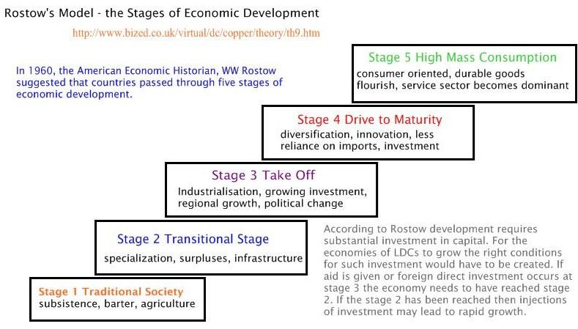

Text dependent questions to consider:
- What are the characteristics of this theory (who, what, where, when, why, etc.)?

- Why might this theory not apply to all states?

- According to Rostow, why are many countries underdeveloped?

- Why might countries not be able to revert to previous stages in this model?

- How does this model help us understand spatial variations of development?

